

**Batch: B1 Roll No: 1914078 Tutorial No.:2**

**Aim:** To implement array data Structures in Python.



**Resources needed:** Python IDE



### Theory:

### An array is a collection of items stored at contiguous memory locations. The idea is to store multiple items of the same type together. This makes it easier to calculate the position of each element by simply adding an offset to a base value, i.e., the memory location of the first element of the array (generally denoted by the name of the array).

### Arrays are sequence types and behave very much like lists, except that the type of objects stored in them is constrained. The type is specified at object creation time by using a *type code*. Array in Python can be created by importing the array module. array(*data_type*, *value_list*) is used to create an array with data type and value list specified in its arguments.

# creating an array with integer type

import array

a = array.array('i', [1, 2, 3])

## Array Methods

Python has a set of built-in methods that you can use on arrays.

|  |  |
| --- | --- |
| **Method** | **Description** |
| [append()](https://www.w3schools.com/python/ref_list_append.asp) | Adds an element at the end of the array |
| [clear()](https://www.w3schools.com/python/ref_list_clear.asp) | Removes all the elements from the array |
| [copy()](https://www.w3schools.com/python/ref_list_copy.asp) | Returns a copy of the array |
| [count()](https://www.w3schools.com/python/ref_list_count.asp) | Returns the number of elements with the specified value |
| [extend()](https://www.w3schools.com/python/ref_list_extend.asp) | Add the elements of an array (or any iterable), to the end of the current array |
| [index()](https://www.w3schools.com/python/ref_list_index.asp) | Returns the index of the first element with the specified value |
| [insert()](https://www.w3schools.com/python/ref_list_insert.asp) | Adds an element at the specified position |
| [pop()](https://www.w3schools.com/python/ref_list_pop.asp) | Removes the element at the specified position |
| [remove()](https://www.w3schools.com/python/ref_list_remove.asp) | Removes the first item with the specified value |
| [reverse()](https://www.w3schools.com/python/ref_list_reverse.asp) | Reverses the array |

### Activity:

1. [Python Program to Split the array and add the first part to the end](https://www.geeksforgeeks.org/python-program-for-split-the-array-and-add-the-first-part-to-the-end/).
2. WAP [for array rotation](https://www.geeksforgeeks.org/python-program-for-program-for-array-rotation-2/) and reverse rotation.

**Program:**

### Code:

import array

def splitArr(arr, n, k):

for i in range(0, k):

x = arr[0]

for j in range(0, n-1):

arr[j] = arr[j + 1]

arr[n-1] = x

arr = array.array('i',[12, 10, 5, 6, 52, 36])

n = len(arr)

position = 3

splitArr(arr, n, position)

print("The array after splitting is: ")

for i in range(0, n):

print(arr[i], end = ' ')

**Output:**

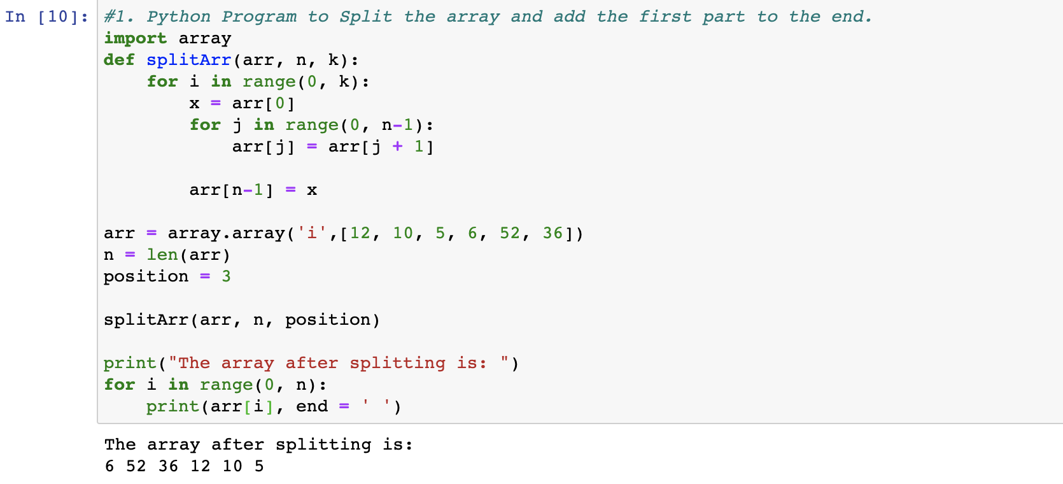

### Code for array rotation:

import array

def leftRotate(arr, d, n):

for i in range(d):

leftRotatebyOne(arr, n)

# Function to left Rotate arr[] of size n by 1*/

def leftRotatebyOne(arr, n):

temp = arr[0]

for i in range(n-1):

arr[i] = arr[i + 1]

arr[n-1] = temp

#function to print an array

print("The array after rotation is: ")

def printArray(arr, size):

for i in range(size):

print ("%d"%arr[i],end =" ")

arr = array.array('i',[1, 2, 3, 4, 5, 6, 7])

leftRotate(arr,1, 7)

printArray(arr, 7)

**Output for Array Rotation:**

### 

### 

### Code for Reverse Array Rotation:

### import array

### def rightRotateByOne(arr,n):

### last = arr[-1]

### for i in reversed(range(n - 1)):

### arr[i + 1] = arr[i]

### arr[0] = last

### # Function to right rotate a list by k positions

### def rightRotate(arr,k,n):

### for i in range(k):

### rightRotateByOne(arr,n)

### arr= array.array('i',[1, 2, 3, 4, 5, 6, 7])

### k = 3

### n=len(arr)

### rightRotate(arr, k,n)

### print("The array after reverse rotation is: ")

### for i in range(n):

### print ("%d"%arr[i],end =" ")

### Output for Reverse Rotation:

### 

### 

### Post Tutorial Questions:

### What are multidimensional arrays? How can it be created in python?

### Ans:

### The concept of Multidimensional Array can be explained as a technique of defining and storing the data in a format with more than two dimensions (2D).

### In Python, Multidimensional Array can be implemented by fitting in a list function inside another list function, which is basically a nesting operation for the list function. Here, a list can have a number of values of any data type that are segregated by a delimiter like a comma. Nesting the list can result in creating a combination of values for creating the multidimensional array.

For example,

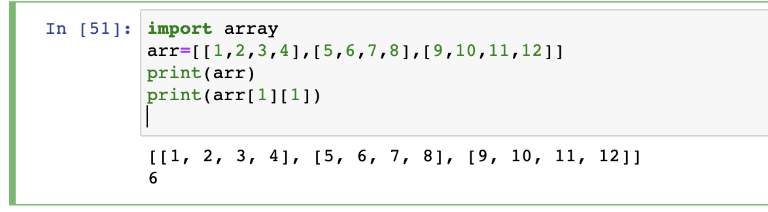

### Outcomes:



Use of Basic Data Structure array in Python



**Conclusion: (Conclusion to be based on the objectives and outcomes achieved)**



Through this experiment we illustrated the use of array data structure in python, and the use of

various built-in methods in the array.







**References:**

1. Reema Thareja , *Python Programing: Using Problem Solving Approach,* Oxford University Press, First Edition 2017, India
2. Dr. R. Nageswara Rao, *Core Python Programming,* Wiley Publication, Second Edition 2018,India
3. Sheetal Taneja and Naveen Kumar, *Python Programing: A Modular Approach,* Pearson India
4. Swarroop C.H, *Byte of python,* e-book, Kindle edition
5. Martin C Brown, *The Complete Reference Python,* Brandon A Nordin, First Edition 2001